Find City Name through zip code using GeoNames web services

From GeoNames website <http://www.geonames.org/export/ws-overview.html> I used following web services:

* [findNearbyPostalCodes](http://www.geonames.org/export/web-services.html#_blank)
* [weather](http://www.geonames.org/export/JSON-webservices.html#_blank)

Downloaded Java Clients and created Java Path using .jar files from <http://www.geonames.org/source-code/>

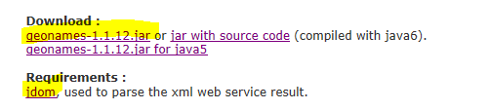

I wrote java code to connect the web services: The code does following features:

* Connect to web service
* Used above class to find zip using latitude and longitudes coordinates
* Code has my user name to connect with webservice
* Code also has lines marked as comment, which can be used to generate a input text box to ask used to connect the web service using user’s username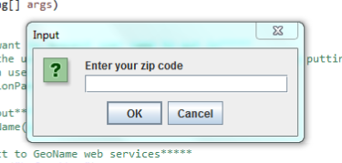
* Generate a input text box to put in Zip Code and press OK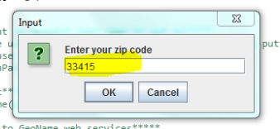
* Generate a message box with city name; also generate result in the console. 